Unit 77: INDOORS
This unit gives you examples of above, at, below, by, downstairs, in, inside, on, out, outside and upstairs when we are talking about things in a building.
Look at this plan of a student hostel.
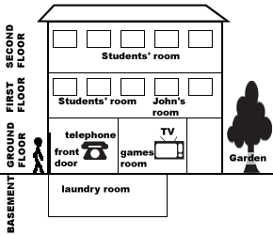
There is a laundry room in the basement.
The games room is on the ground floor
John’s room is on the first floor.
The games room is below John’s room.
There is a TV in the games room.
There is somebody at the front door (waiting to come in).
There is a telephone by the front door.
There is a garden at the back.
The students’ rooms are upstairs / above the ground floor.
The games room is downstairs from the students’ rooms.
NOTICE
Is John in today? (Is he in the hostel?)
I’m afraid John is out at the moment. (He is not in the hostel.)
NOTICE
It was beautiful in the garden, but then it began to rain, so we went inside.
When the rain stopped, the children ran outside to play.
We can also use indoors and outdoors in these sentences.

